**The Assignment:**

You will create a brief report that provides a brief overview of the company, what it does, and your interpretation of their financial position. Elements of the report are outlined below. Assume your report is going to your boss, and so needs to reflect the professionalism that you would want to convey (meaning it is detailed yet concise, reads well and is free of typos and grammatical errors).

**Part 1. Company Overview (25 points)**

First select a company that trades on either the NYSE or NASDAQ. The company may or may not be a U.S.-based company, but it needs to provide publicly available annual financial reports (either the company’s Annual Report or their 10-K SEC Filing). You can find this information on the company’s website, often under the “Investors” section.

Ideally, the company’s products (or services) are of a technical nature, as that is likely the sort of company you are working for, or perhaps want to work for some day. Also, try to be creative; while Apple and Google come to everyone’s mind as interesting tech companies, there are many more businesses out there worth evaluating (and working for!).

In this first section, provide a brief overview of the company in terms of typical company statistics: what industry it is in, where it is located, and how many people are employed there. You will find much of this information in the company’s Annual Report, often at the very beginning.

**Part 2. Products (or Services) (25 points**)

In this section, describe the products or services the company provides. You’ll find much of this information in both the Annual Report and 10-K. Be specific; for example, don’t say “Apple sells phones and computers”, but get into the sort of details outlined in the reports: “Apples product lines include the Macbook computers, iPhone mobile phones, iPad tablets, ….”. You get the idea. The 10-K Report has a section specifically dedicated to this. See the Appendix for where to find this information.

**Part 3. Your Analysis (25 Points)**

Now it comes time to provide your own analysis of each financial statement. This should be a short description, perhaps just a few sentences, of what happened in the most recent year. For example, you might read *“2021 showed an increase in revenues of 10% due to an 18% increase in sales of electric vehicles.”.* Simply tell this story in your own words. Or you might read “*Operating expenses decreased due to a restructuring of our workforce to better align with market conditions”*, which is the corporate way of saying the company laid off a significant percentage of its employees to reduce costs.

You do not need to go through each line item in each financial statement, just try to highlight the significant changes that occurred. And put the reasons for the change in your own words, taking the corporate-speak and interpreting what really happened.

**Part 4. Financial Statements (25 points)**

In these sections, paste a screenshot of the company’s Income Statement, Balance Sheet and Statement of Cash Flows into the space provided. An excellent source for these are the 10-K Report. See the Appendix for where to find them. Also – be aware that there are several of them in the 10-K, many more than we covered in the class. Make sure you find the three required for the assignment!

*Good luck and have some fun with this one!*

*Answer Sheet Format – learners should complete their responses within the boxes below and upload as a pdf to be peer-reviewed.*

| Corporate Financial Analysis: *(Company Name)* |
| --- |
| 1. Company Overview: |
| 1. Products and/or Services: |
| 1. Financial Analysis:   Income Statement:  Balance Sheet:  Statement of Cash Flows: |
| 4A. The Income Statement *(Post a screenshot of the company’s Income Statement here.)* |
| 4B. The Balance Sheet *(Post a screenshot of the company’s Balance Sheet here.)* |
| 4C. The Statement of Cash Flows *(Post a screenshot of the company’s Statement of Cash Flows here.)* |

**Appendix.**

If you use a company’s 10-K Filing, they all have the same format – regardless of company. That makes it easy for investors to go to the right section of the report for the information they need.

The image below shows the Table of Contents of a typical 10-K report.

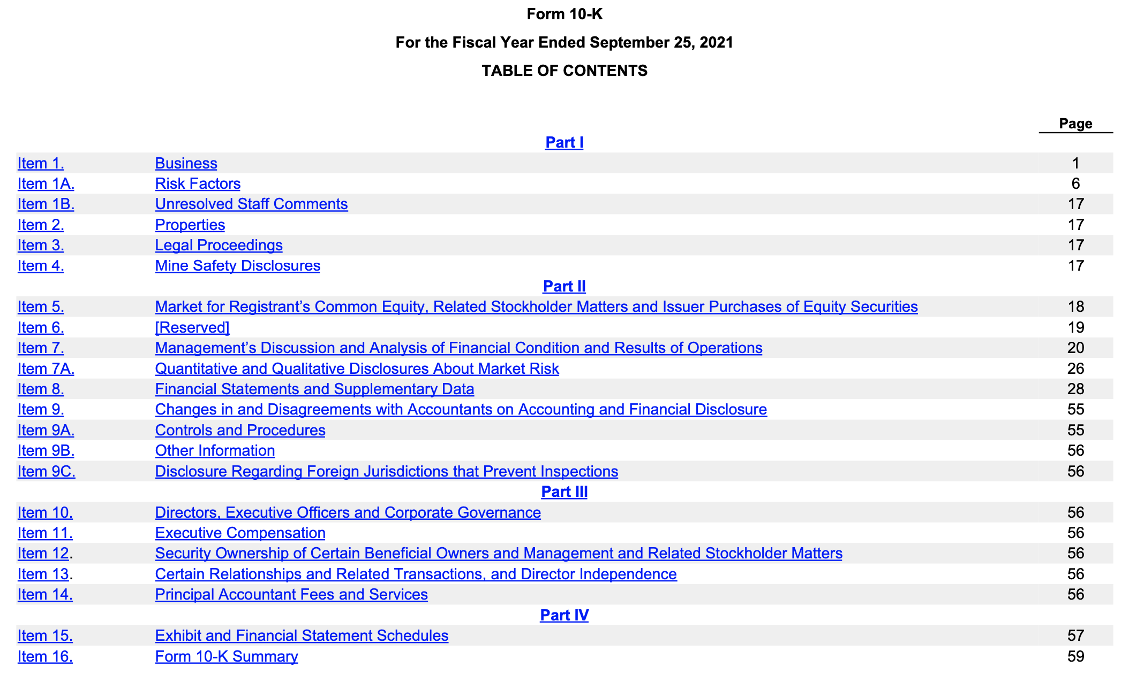

An overview of the company and its products can be found in Item 1. The financial statements are all found in Item 8. There are several of them, so make sure you find those required for the assignment!